**Title:** Birth Certificates on FHIR

**Purpose:** The collection and submission of birth certificate information to state vital statistics agencies is currently the responsibility of birth certificate clerks, typically staff in medical records departments of hospitals. For each birth occurring in a hospital, birth clerks are required to abstract clinical information from the records of both the mother and the newborn. This information is hand-written onto a *facility worksheet.*  A second worksheet,  *the mother’s worksheet,*  is completed by the mother and father, if applicable, and contains demographic information about the parents and the desired name of the newborn child. Both worksheets are entered into a web-based form called an electronic birth registration system (EBRS) and submitted to the state health department birth certificate registry.

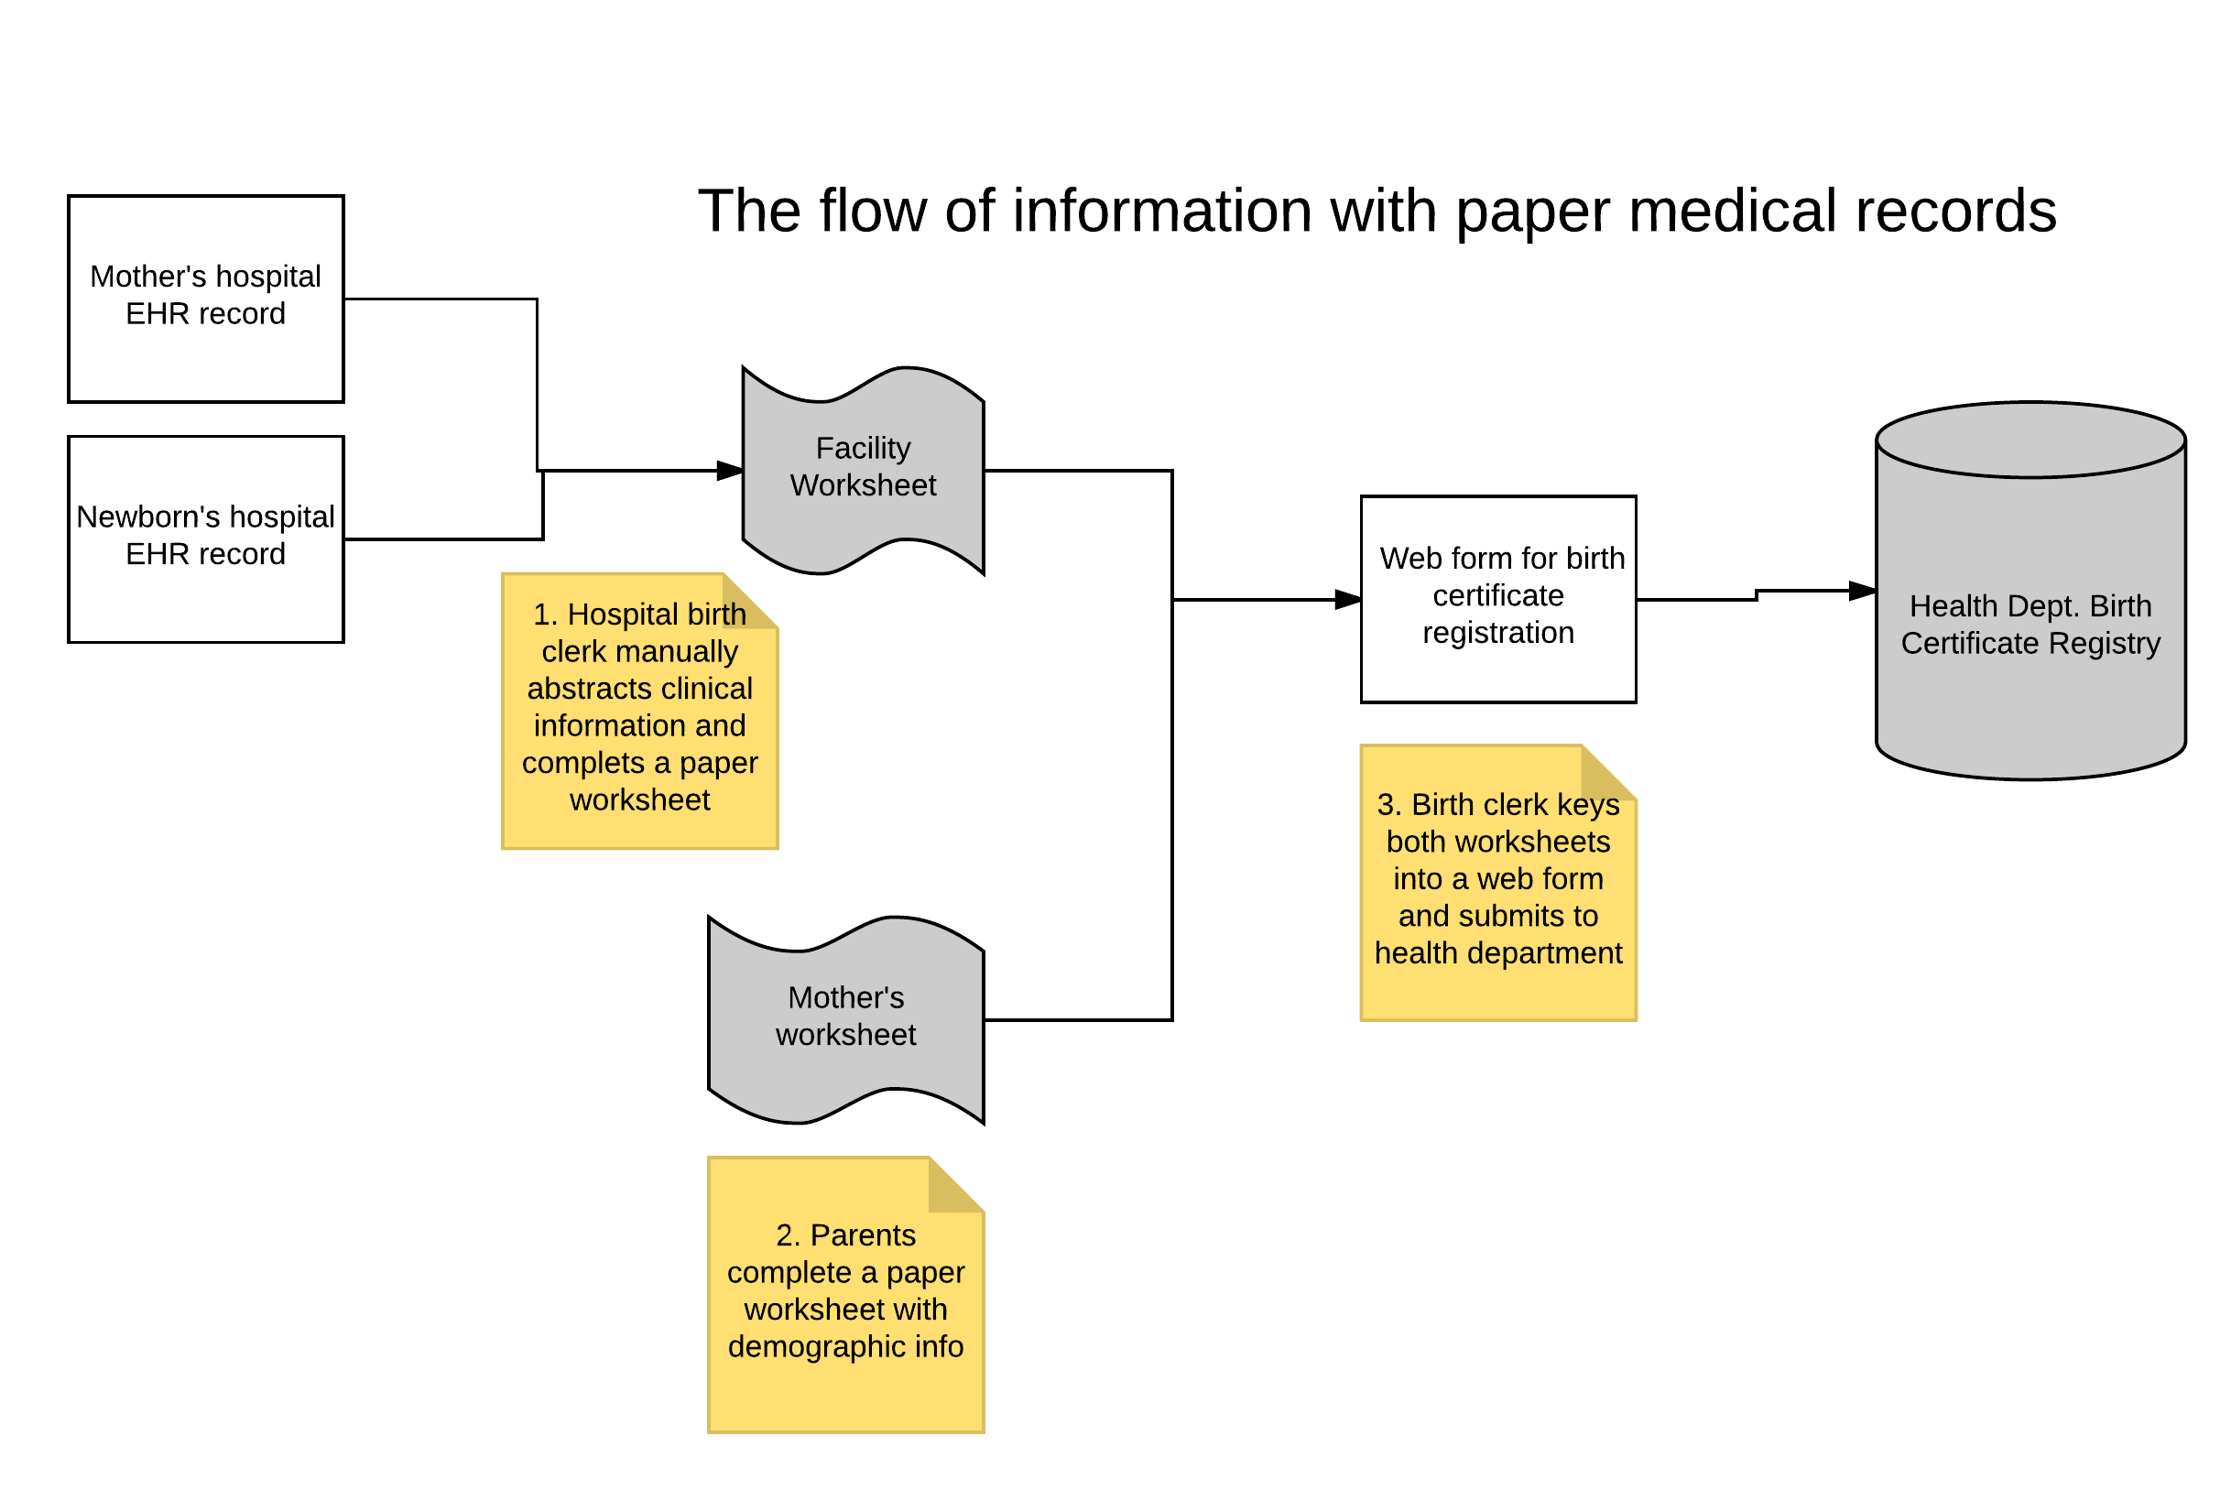

**Figure 1. Current birth certificate process**

The process of manually abstracting information from mother and child records is labor intensive and error prone, and dates back to the time of paper medical records. Birth clerks also must be trained on the precise definitions of information required to be reported on the birth certificate, and their performance is routinely audited by the state with a focus on maintaining and improving quality.

The increasing adoption of electronic health records (EHRs) in the past few years has spawned several initiatives focused on replacing the manual abstraction of clinical information from mother’s and newborn’s EHRs. Integrating the Healthcare Enterprise (IHE) has developed standards for the exchange of birth and death certificates from EHRs using both HL7 C-CDA and HL-7 version 2.6 messaging approaches, but these have not yet been adopted in any production systems, and uptake has been slow on the part of EHR and vital statistics system vendors. Because these standards are difficult to implement.

**Proposed Solution:** The HL7 Fast Healthcare Interoperability (FHIR) approach to obtaining birth certificate information from EHRs may be preferable to the IHE integration profiles that have been developed because FHIR may be easily integrated into existing vendor systems. Use of SMART-on-FHIR in particular promises to allow for the inclusion of much of the logic currently performed by birth clerks, resulting in more accurate and reliable data collection across facilities and jurisdictions. A high level architecture of how this might work is shown in Figure 1.

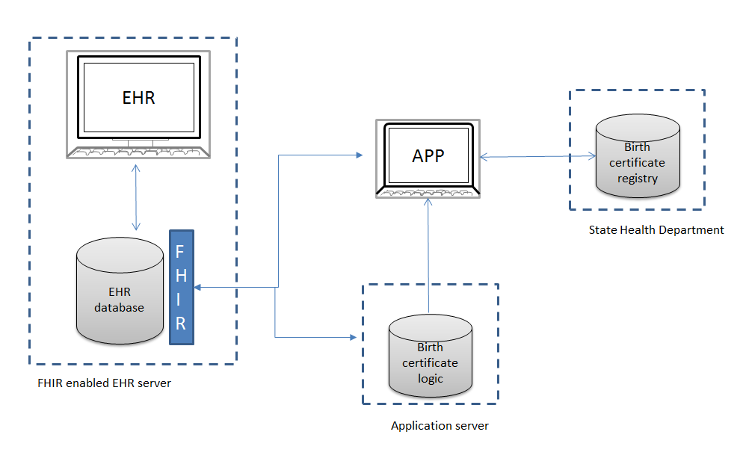

**Figure 2. High Level architecture for Birth Reporting Application**

**Project Overview**

The scope of this project would be to develop the FHIR resource mappings and birth certificate logic to support a SMART-on-FHIR application for birth certificate clerks.

A birth certificate clerk in the EHR would launch the birth certificate app.

The app would then fetch the necessary data elements, using the EHR’s FHIR port.

Other data (e.g. mother’s worksheet) could then be manually entered by the birth certificate clerk directly into the app.  The app is essentially performing the role of a smart form tool, using HTML to manage the UX.

The app then submits to the birth registry using http post. (In production we would use an encrypted transmission but for the purposes of this class encryption is not necessary.)

**Scope**

The birth certificate is a fairly large document and extracting all of the needed clinical information is beyond the scope of a single class. For this project, the focus will be on developing a framework for a SMART-on-FHIR app and implementing content from a subset of the birth certificate, as well as limited demographic fields.

The content on a birth certificate can be divided into sections of related content such as:

* Mother prenatal information
* Maternal Risk factors
* Labor and Delivery
* Newborn medical

Review the certificate of live birth document (<https://www.cdc.gov/nchs/data/dvs/birth11-03final-acc.pdf>) The team should choose a subject of related birth certificate information to include in the scope of this project. In addition, each team should include a small subset of information to be keyed from the mother’s worksheet, such as newborn child’s name, parent’s names, and so on.

Steps:

1. Choose a subset of birth certificate information after reviewing the standard birth certificate.
2. Map birth certificate data elements for each discrete subset identified in (1) to FHIR resource definitions.
3. For each data element selected, develop logic for the application to translate EHR values to birth certificate values. (For example, the birth certificate defines *precipitous labor* as labor that is < 3 hours in duration. The EHR may store the time of onset of labor, and the time of delivery, so the application would need to calculate the duration of labor and check the box on the HTML data entry form for precipitous labor if < 3 hours.)
4. Develop a SMART-on-FHIR birth certificate webform and application
5. Develop a SMART-on-FHIR module with logic specific to the subset that will either pre-populate the birth form or otherwise provide the birth clerk with decision support.